1.) COSINE WAVE

|  |  |  |
| --- | --- | --- |
| Sr. No. | AMPLITUDE (mV) | FREQUENCY (kHz) |
| 1 | 1 | 10 |
| 2 | 1 | 20 |
| 3 | 2 | 10 |
| 4 | 2 | 20 |
| 5 | 2 | 15 |

*Case 1: Amplitude: 1 mV || Frequency: 10 kHz*

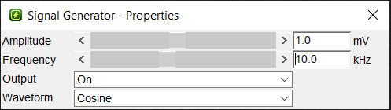

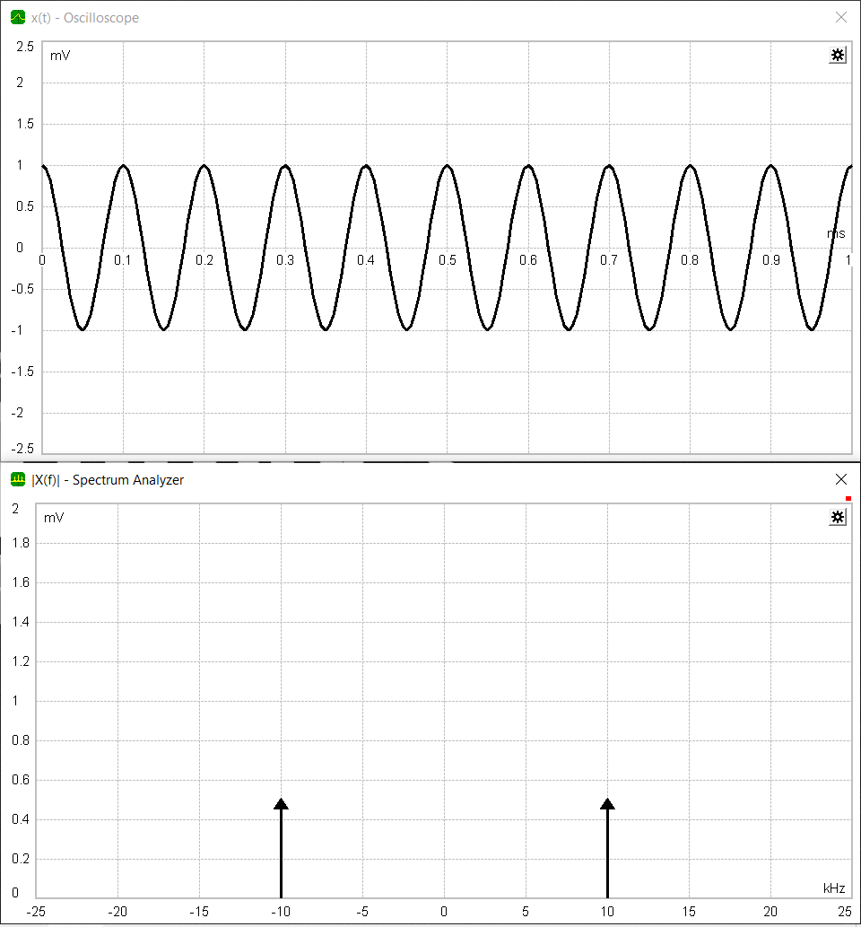

*Case 2: Amplitude: 1 mV || Frequency: 20 kHz*

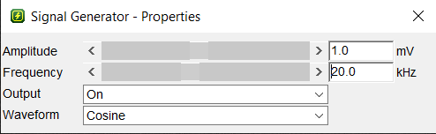

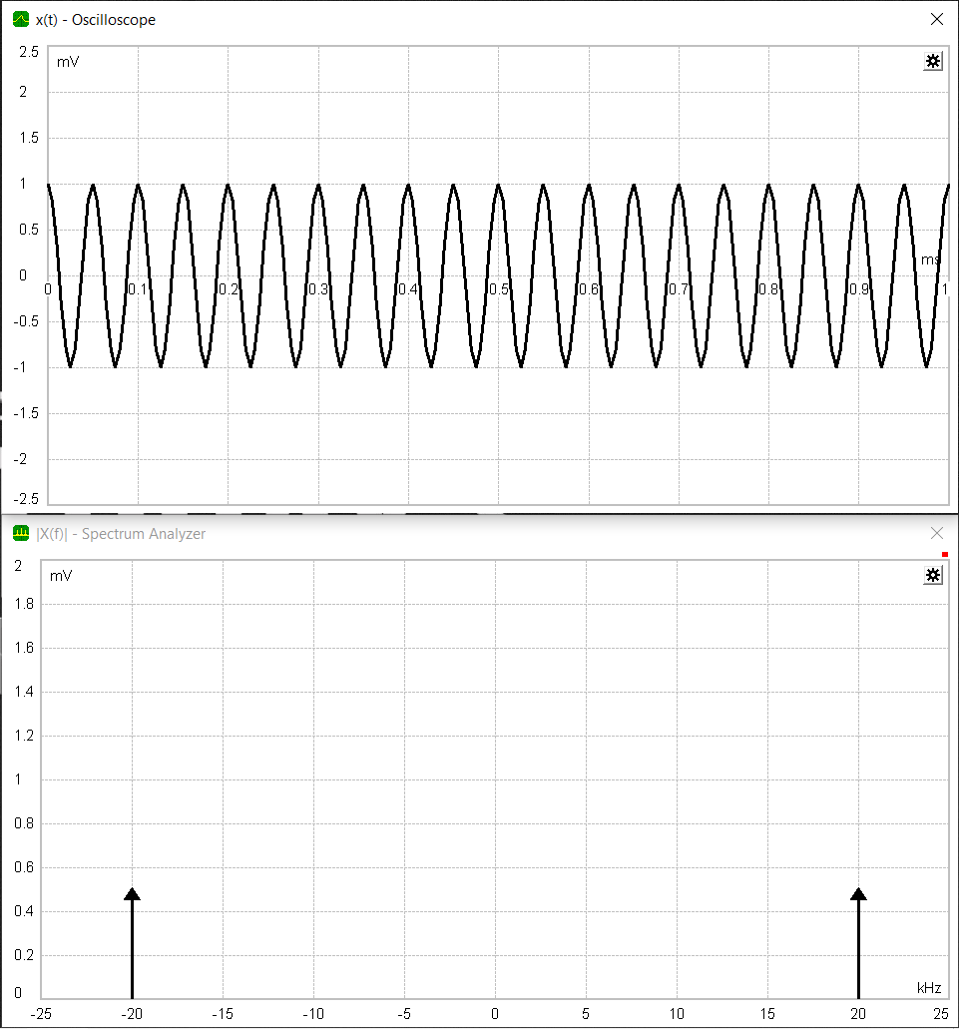

*Case 3: Amplitude: 2 mV || Frequency: 10 kHz*

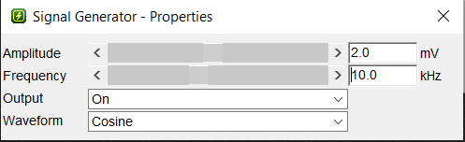

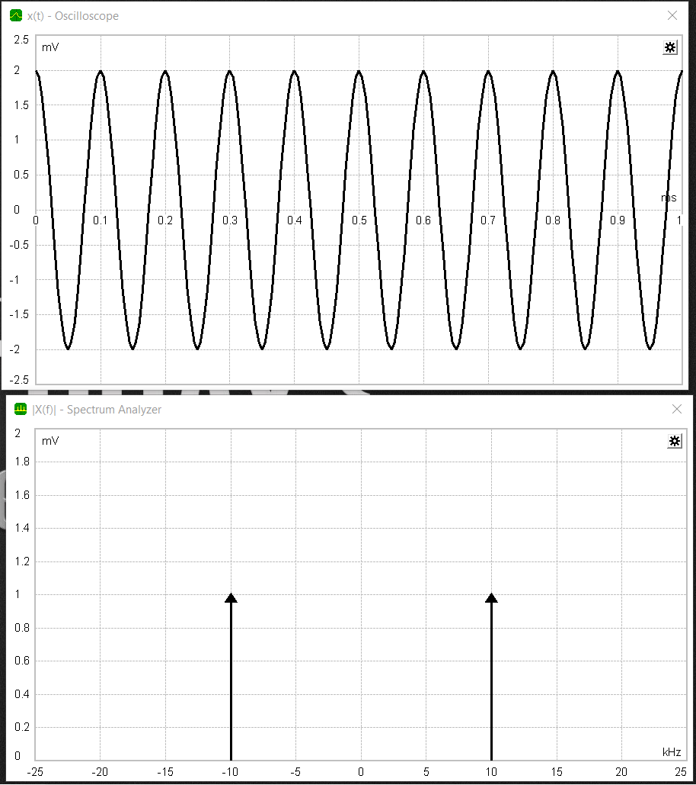

*Case 4: Amplitude: 2 mV || Frequency: 20 kHz*

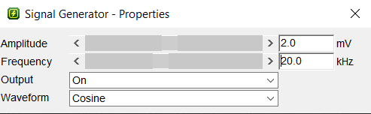

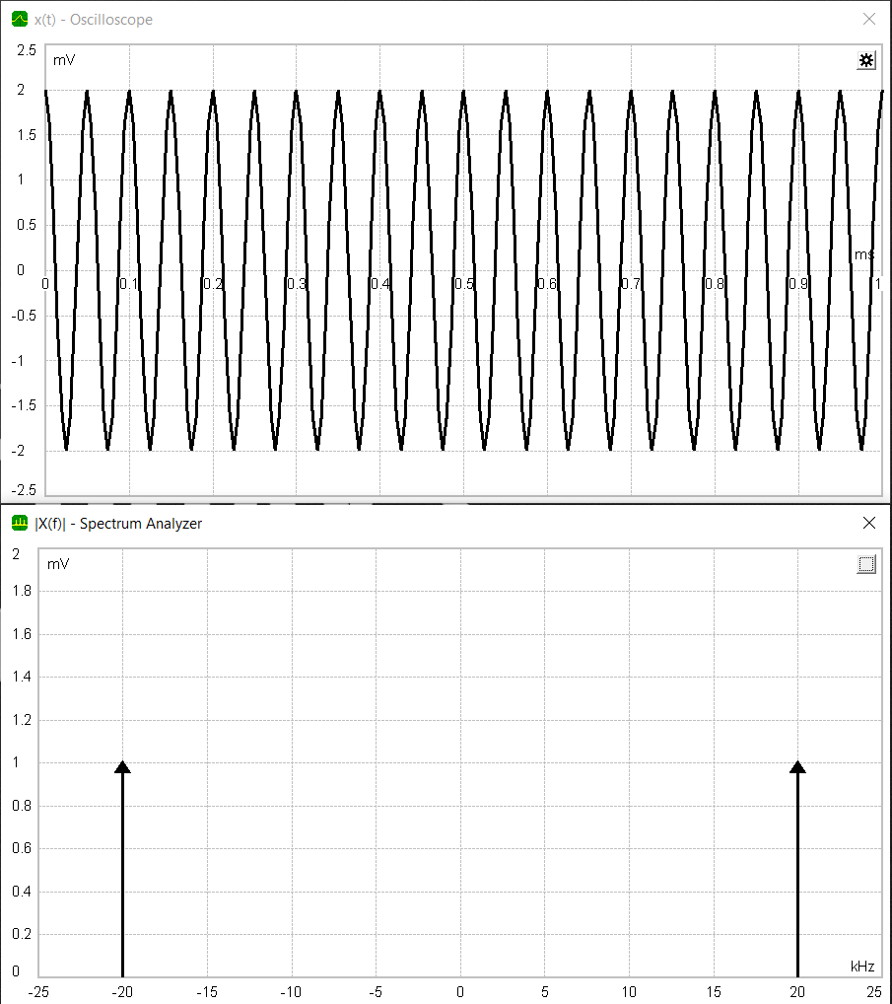

*Case 5: Amplitude: 2 mV || Frequency: 15 kHz*

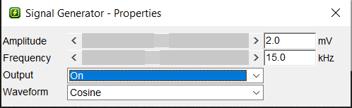

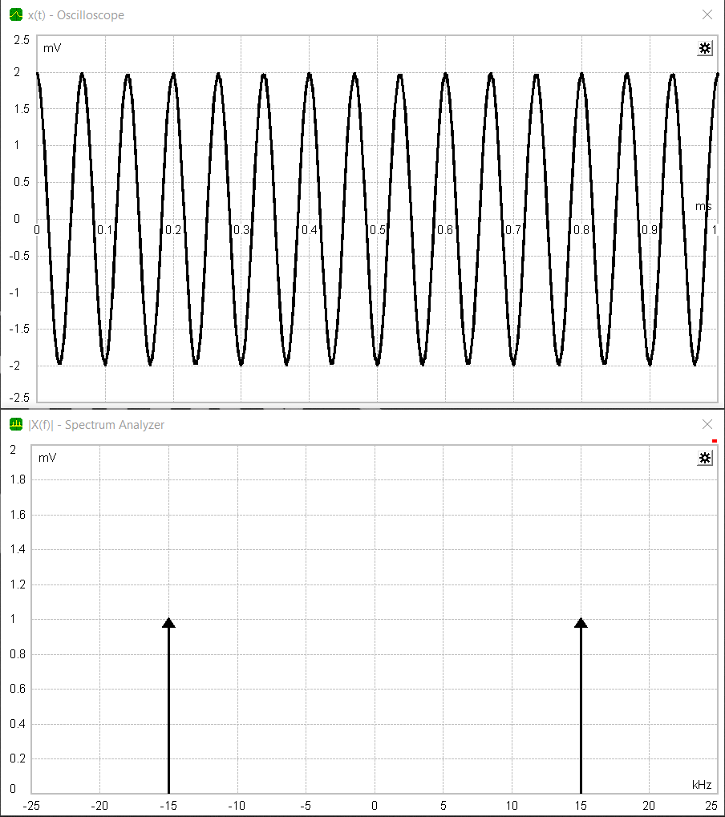

1.) SQUARE WAVE

|  |  |  |
| --- | --- | --- |
| Sr. No. | AMPLITUDE (mV) | FREQUENCY (kHz) |
| 1 | 1 | 10 |
| 2 | 1 | 20 |
| 3 | 2 | 10 |
| 4 | 2 | 20 |
| 5 | 2 | 15 |

*Case 1: Amplitude: 1 mV || Frequency: 10 kHz*

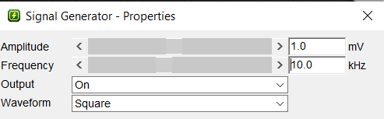

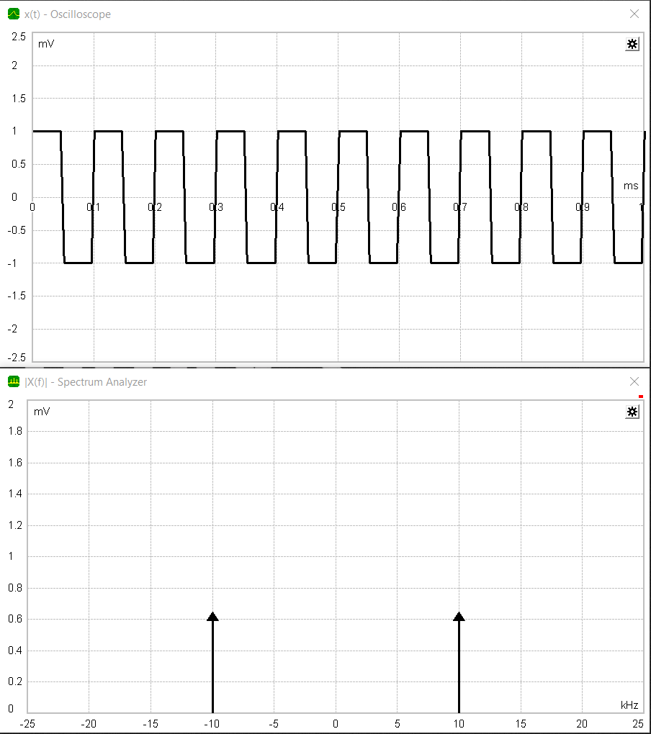

*Case 2: Amplitude: 1 mV || Frequency: 20 kHz*

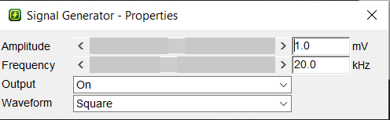

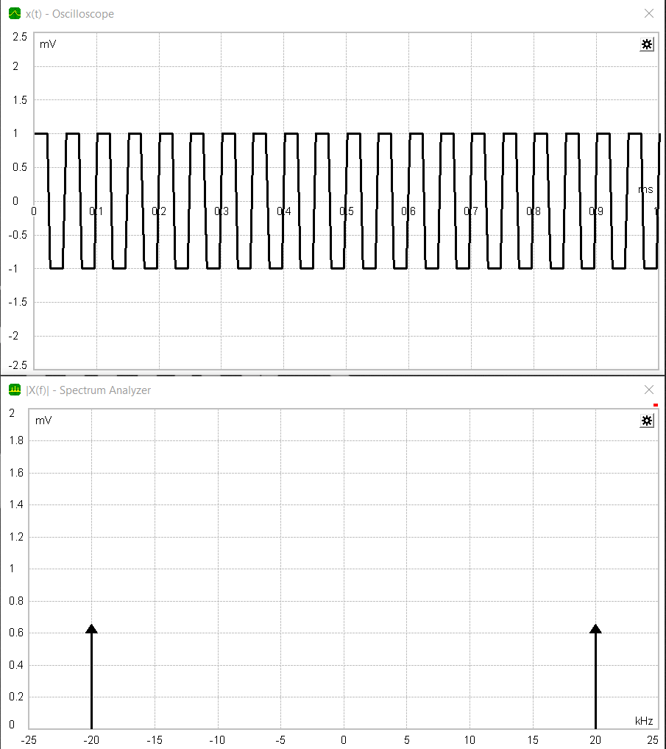

*Case 3: Amplitude: 2 mV || Frequency: 10 kHz*

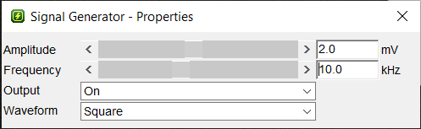

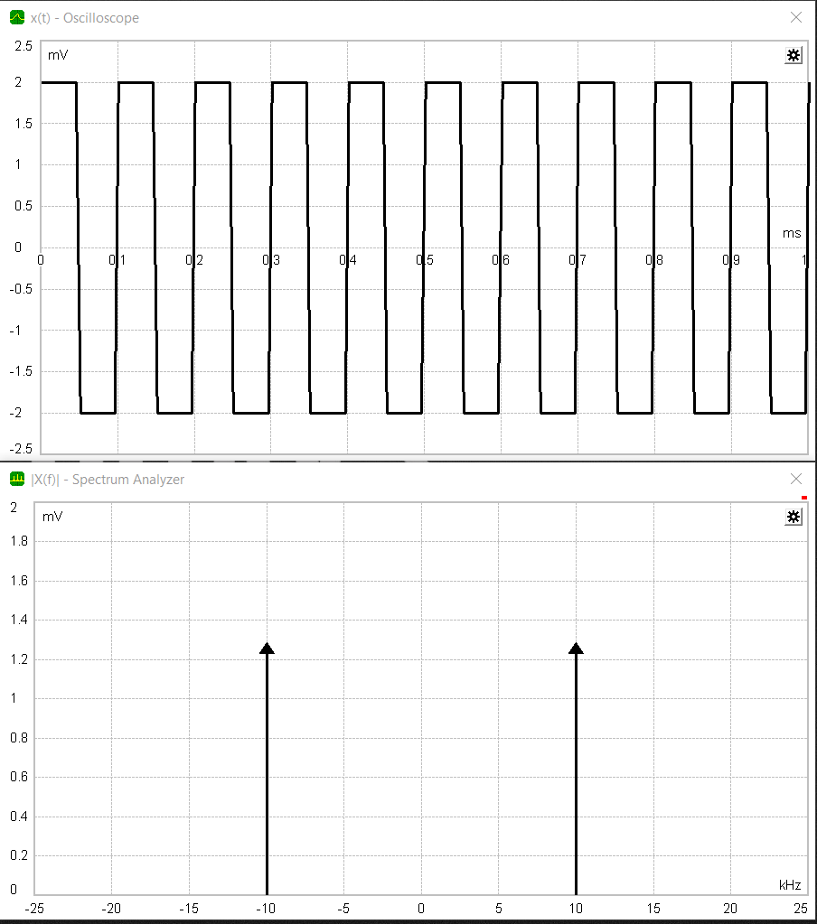

*Case 4: Amplitude: 2 mV || Frequency: 20 kHz*

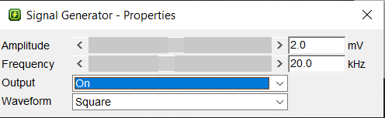

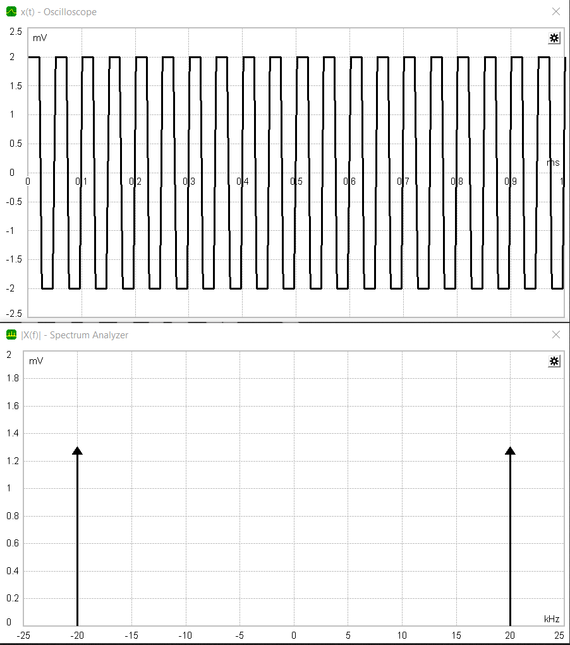

*Case 5: Amplitude: 2 mV || Frequency: 15 kHz*

